Name___________________________

Continental Drift Worksheet

Fill in the blank with the correct word.

Types of Evidence | Examples of Evidence
Evidence from 1. ______________________ | - Mountain ranges in South America and 2.___________________ line up  - European coal fields match with similar coal fields in North America
Evidence from Fossils | - Fossils of the plant 3.___________________ found in rocks on widely separated landmasses
Evidence from 4. _____________________ | - Fossils of tropical plants found near Arctic Ocean  - Scratches in rocks made by 5._____________ found in South Africa

6) State the Theory of Continental Drift.

7. Why did most scientists reject Wegner’s theory for nearly a half a century?

8. What was the name of the large “supercontinent” formed when all of the continents were joined together?

9) What is a fossil?

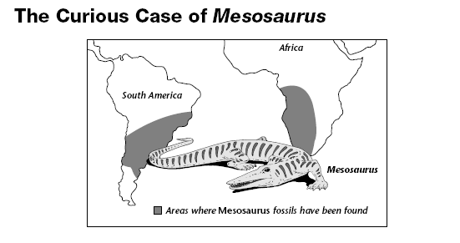

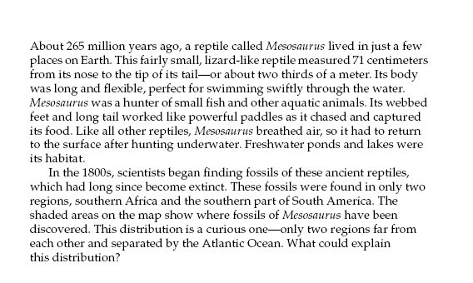

1) Describe the kind of environment in which Mesosaurus lived.

2) Is it likely that Mesosaurus swam back and forth across the Atlantic Ocean? Why or Why not?

3) What could explain this distribution of Mesosaurus fossils?

4) Does the case of Mesosaurus support Wegner’s theory of continental drift? Explain why or why not.

